Task 1: Linear Regression Analysis

Krescens Kok
Department of Technology, Western Governors University
D600: Statistical Data Mining
Keiona Middleton
2025 October 1

A. Create your subgroup and project in GitLab using the provided web link by doing the following:
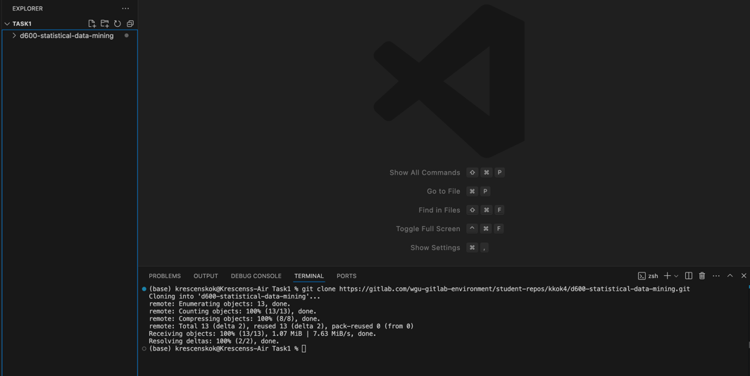
• Clone the project to the IDE.

• Submit a copy of the GitLab repository URL in the "Comments to Evaluator" section when you submit this assessment.

https://gitlab.com/wgu-gitlab-environment/student-repos/kkok4/d600-statistical-data-mining

• Submit a copy of the repository branch history retrieved from your repository, which must include the commit messages and dates.

https://gitlab.com/wgu-gitlab-environment/student-repos/kkok4/d600-statistical-data-mining/-/commits/main?ref_type=HEADS

B. Describe the purpose of this data analysis by doing the following:
1. Propose one research question that is relevant to a real-world organizational situation captured in the provided dataset that you will answer using multiple linear regression in the initial model.

Research Question: Can I predict house prices?

2. Define one goal of the data analysis. Ensure that your goal is reasonable within the scope of the scenario and is represented in the available data.

The goal of this data analysis is to identify whether I can predict house prices based on information such as the number of rooms, bathrooms, fireplaces, etc., by using a multiple linear regression model. A linear regression model is great for modeling the relationship between a dependent variable and one or more independent variables. It is typically used for predicting outcomes and understanding variable relationships.
C. Summarize the data preparation process for multiple linear regression analysis by doing the following:
1. Identify the dependent and all independent variables that are required to answer the research question and justify your selection of variables.

The dependent variable is the ‘Price’ that represents the price of the house. All other variables, except for ID, in the dataset are the independent variables; however, not all of these variables may be included in the final model due to variable selection.

SquareFootage: I kept this because it makes sense that the bigger the square footage of a house, the higher the price will be, so it’s possible that this could have an impact on the dependent variable.
NumBathrooms/NumBedrooms: A lot of buyers look at how many bathrooms and bedrooms there in a house, which impacts how much a house will be. I kept these features because it could cause the house price to go up or down depending on the number.
BackyardSpace: I kept this because backyard space and land are valuable to a house for families with children, dogs, etc, so this could have an impact on the house price.
CrimeRate: I kept this because the crime rate tells more about the kind of area a house is in, which could impact the price.
SchoolRating: I kept this because the school rating could determine the price of the house, based on whether it is in a good school district or not. If it’s a good school district, more families will want to live there, driving the house prices up.
AgeOfHome: This could have an impact on price because if the house is really old, there may be a lot of things to fix, which could decrease the value of the house.
DistanceToCityCenter: This is important because some buyers want to be near the city center, which increases the demand for houses nearby, and therefore could have an impact on the house price.
EmploymentRate: This could have an impact on the house prices because the employement rate might tell someone how easy or hard it is to get a job around the area, and also will determine what kind of neighborhood it might be.
PropertyTaxRate: This could have an impact on the house prices because if there is a high tax rate, the house price might be lower so it is more affordable.
RenovationQuality: This could have an impact on the house prices because if the renovation quality is low, then the value of the house might be lower, causing the house price to go down.
LocalAmenities: This could have an impact on the house prices because people want to live close to amenities, like gyms or grocery stores, which could drive the demand up for certain houses, causing the prices to go up.
TransportAccess: Transportation can be a big deal to people, so having more access to public buses or trains could impact the demand for a house, causing the price to increase.
Fireplace: Some people really enjoy having a fireplace in the house, especially in colder places, so this could cause the house price to go up.
HouseColor: This could impact the house price because if a house is an ugly color, it may be less attractive to people, causing the house price to go down.
Garage: This could impact the house price because people enjoy having a garage to park their cars or store things.
Floors: Some people enjoy having multiple floors and some enjoy having a ranch style house. This could impact the house price based on the demand and preference.
Windows: Most people enjoy having natural light in their house so having more windows could cause the house price to go up.
PreviousSalePrice: Depending on the time period, most house prices don’t go down, so when a seller wants to sell the house, they might look at what it previously sold for, causing the house price to start at a higher price.
isLuxury: If it is a luxury house, the demand for that house might go up, causing the house price to go up as well.

ID was excluded because the linear regression model looks for patterns in the data, and the ID column does not have any sort of pattern in relation to the price of the house.

2. Describe the dependent variable and all independent variables from part C1 using descriptive statistics (counts, means, modes, ranges, min/max), including a screenshot of the descriptive statistics output for each of these variables.

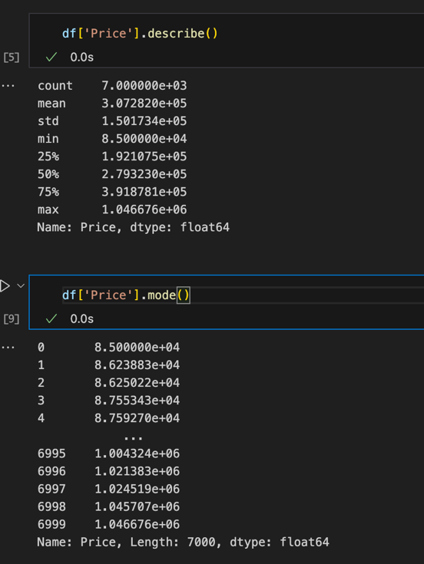
Dependent Variable:

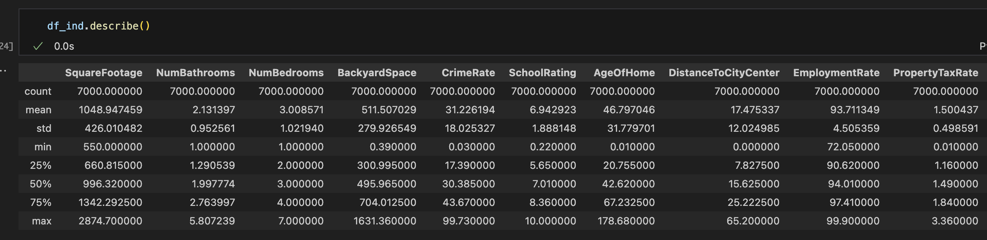
Independent Variables:

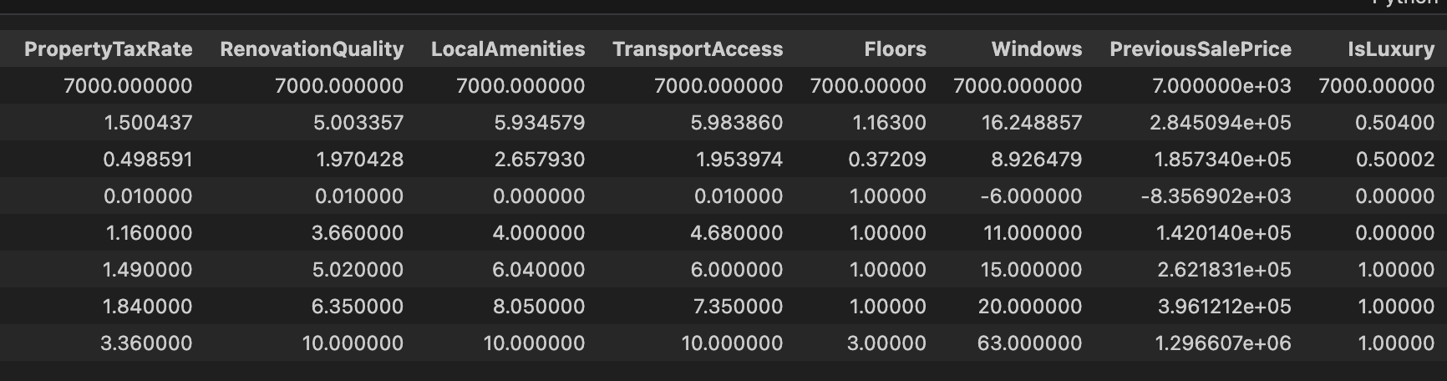
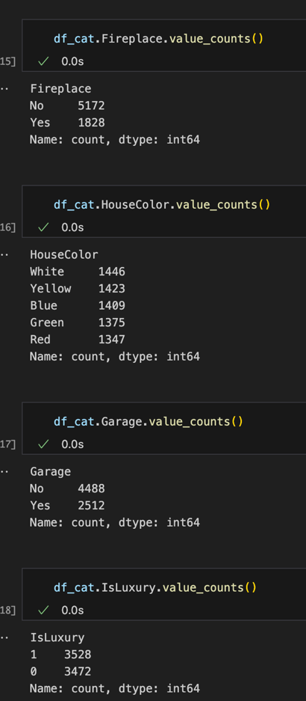
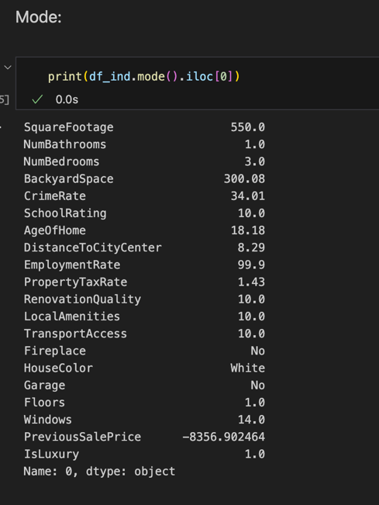
Value counts for categorical variables:

3. Generate univariate and bivariate visualizations of the distributions of the dependent and independent variables from part C1, including the dependent variable in the bivariate visualizations.

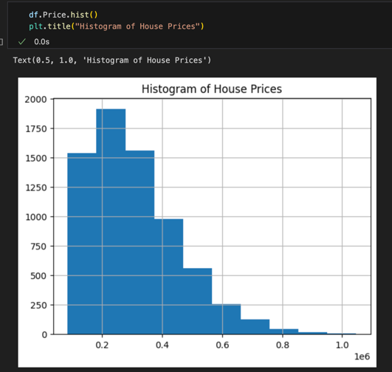
Univariate Visualizations:
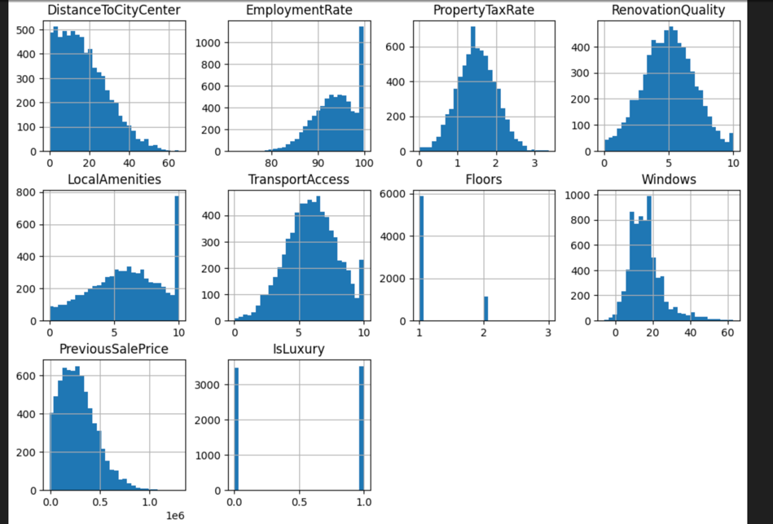
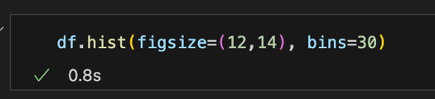
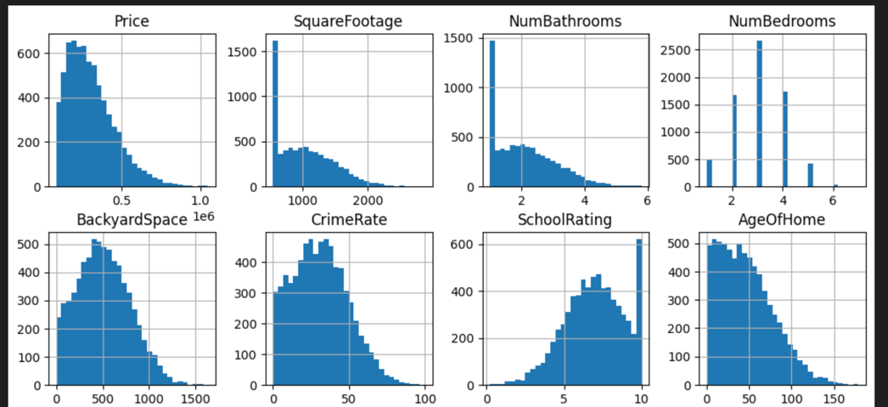
Bivariate Visualizations:
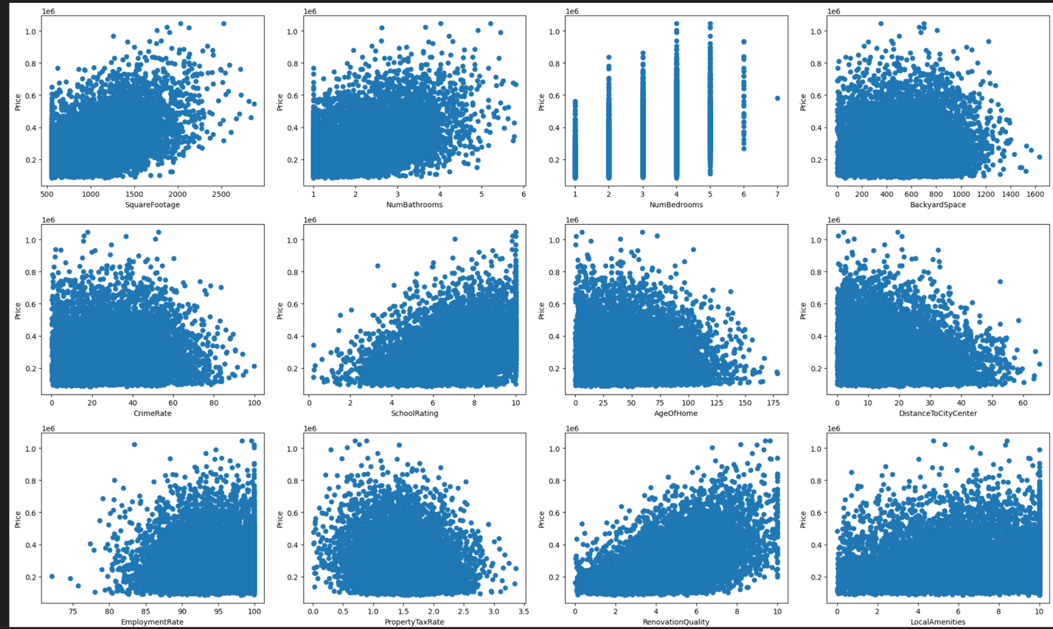
Numerical independent variables:
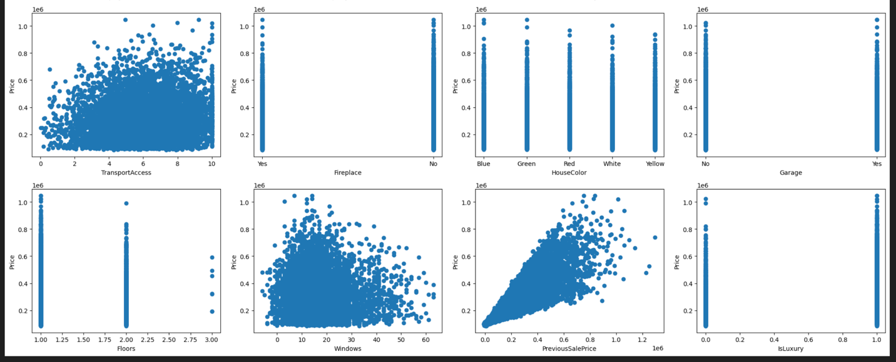

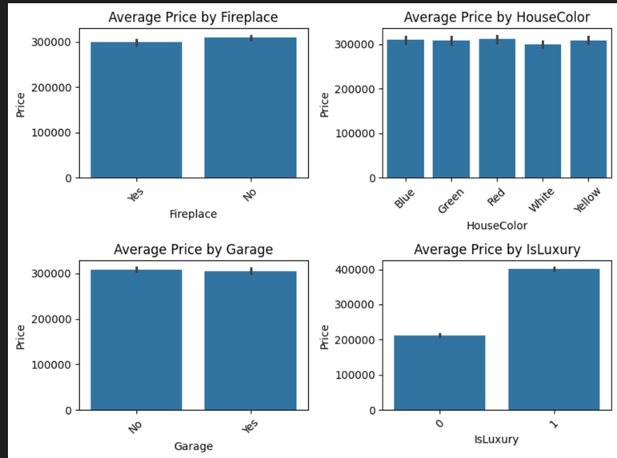
Categorical independent variables:

D. Perform the data analysis and report on the results by doing the following:
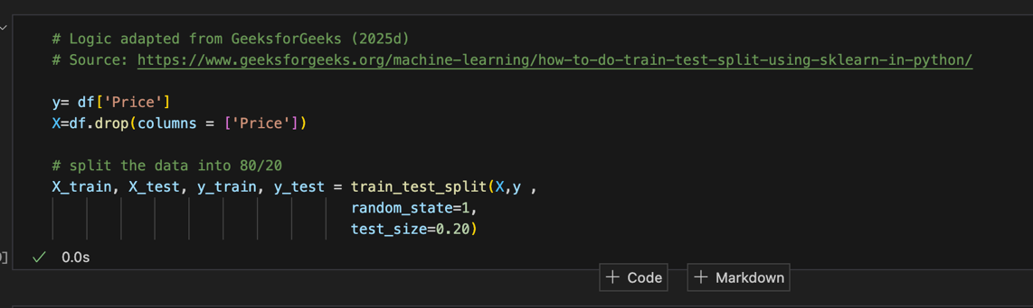
1. Split the data into two datasets, with a larger percentage assigned to the training dataset and a smaller percentage assigned to the test data set. Provide the files.

Files are uploaded with the submission as follows:
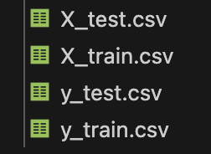

2. Use the training dataset to create and perform a regression model using regression as a statistical method. Optimize the regression model using a process of your selection, including but not limited to, forward stepwise selection, backward stepwise elimination, and recursive selection. Provide a screenshot of the summary of the optimized model or the following extracted model parameters:

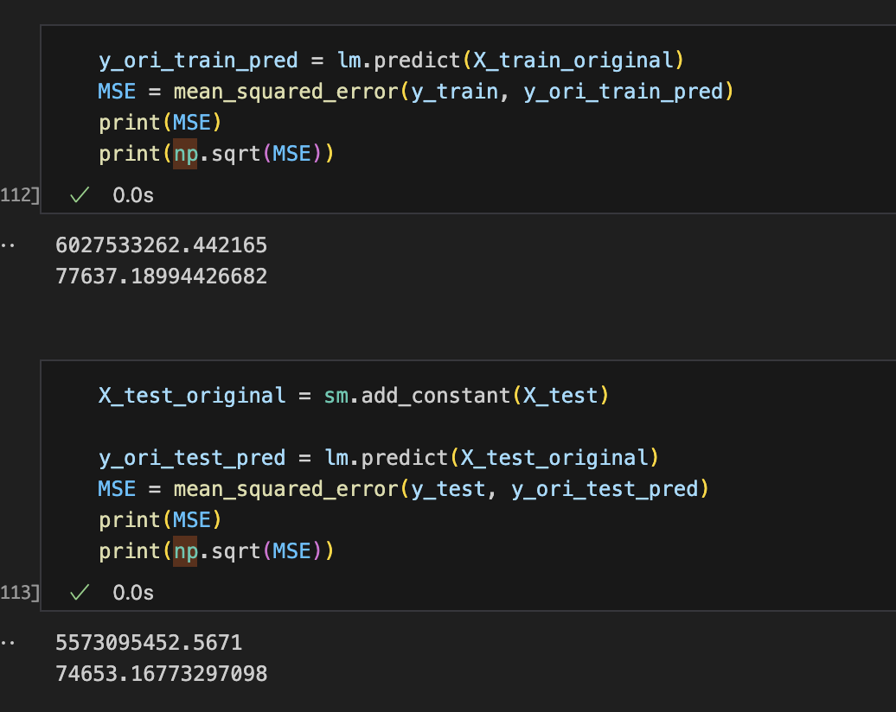
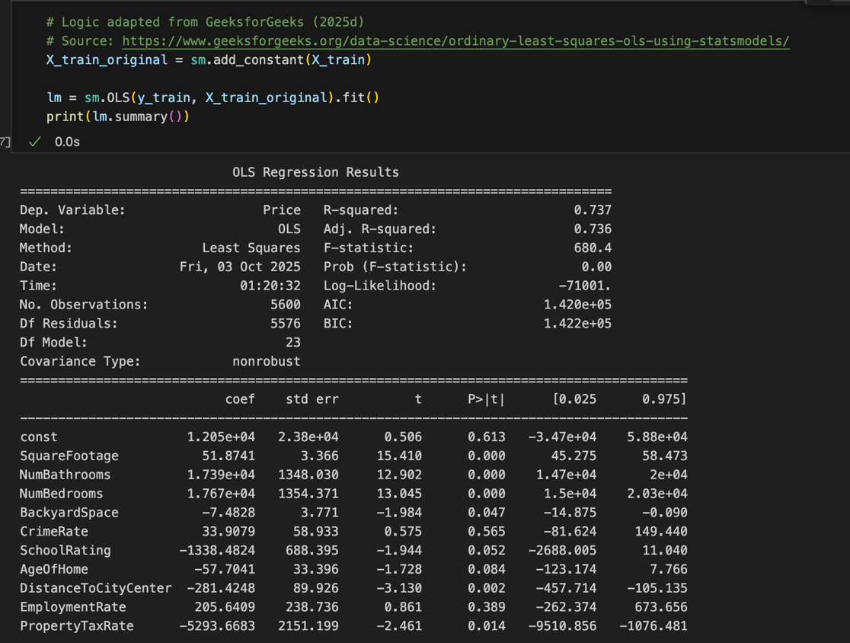
Performing the OLS regression before backward stepwise elimination:

Backwards Stepwise Elimination:

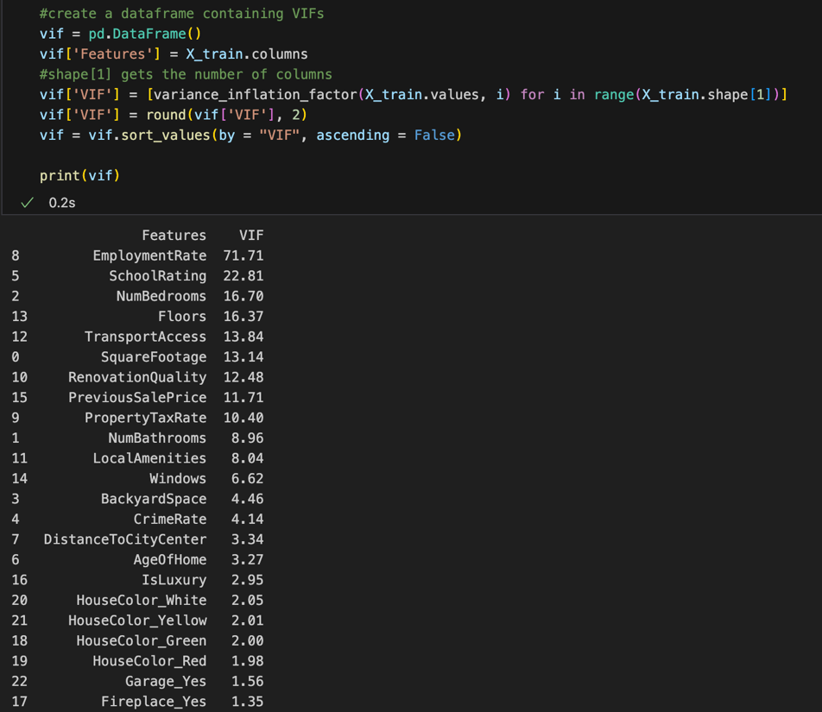
Before performing the stepwise elimination, we need to ensure that there is no multicollinearity with the features. In order to do this, I used the variance inflation factor function on the dataset to identify the variables that had a high correlation factor with other variables. I removed the variable with the highest VIF score one by one until the VIF scores were below 15.

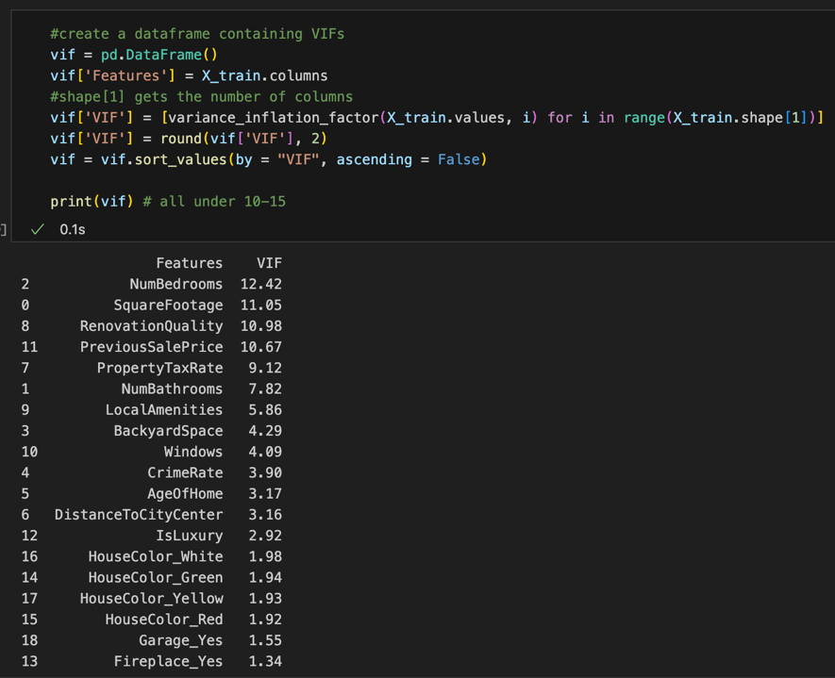
After removing variables:

Remove features with backwards stepwise elimination:
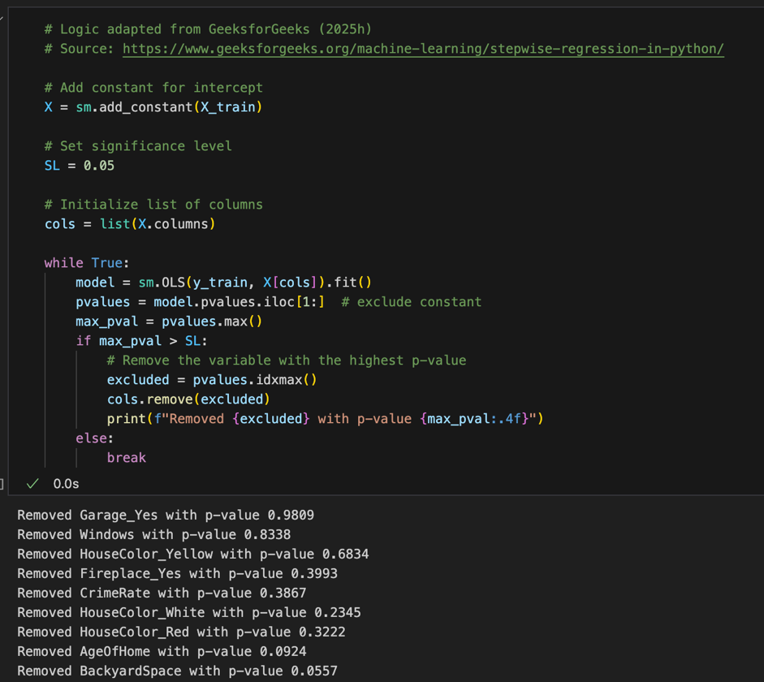
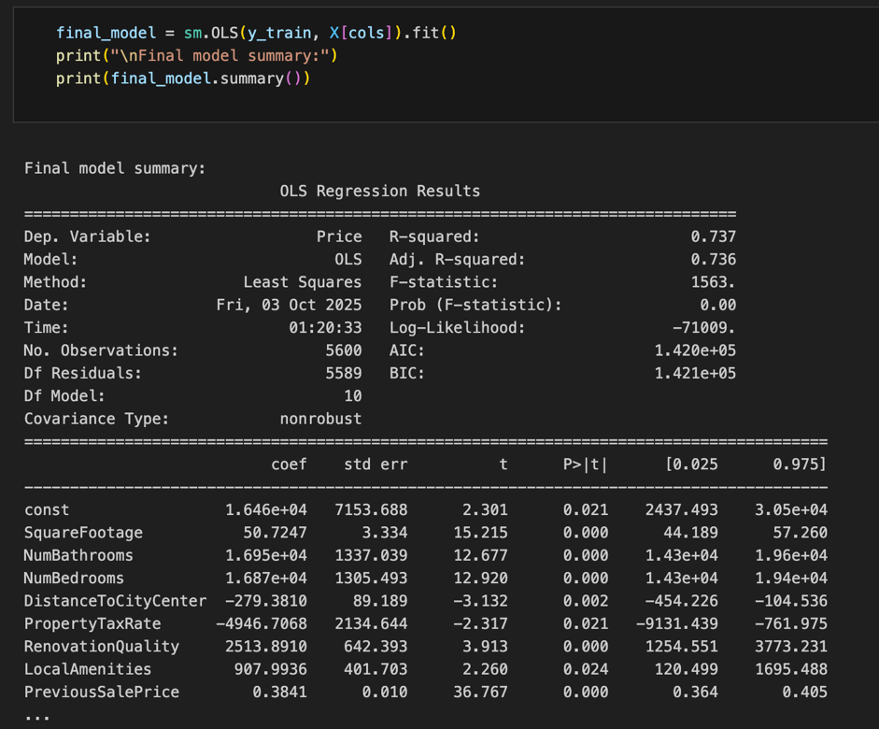

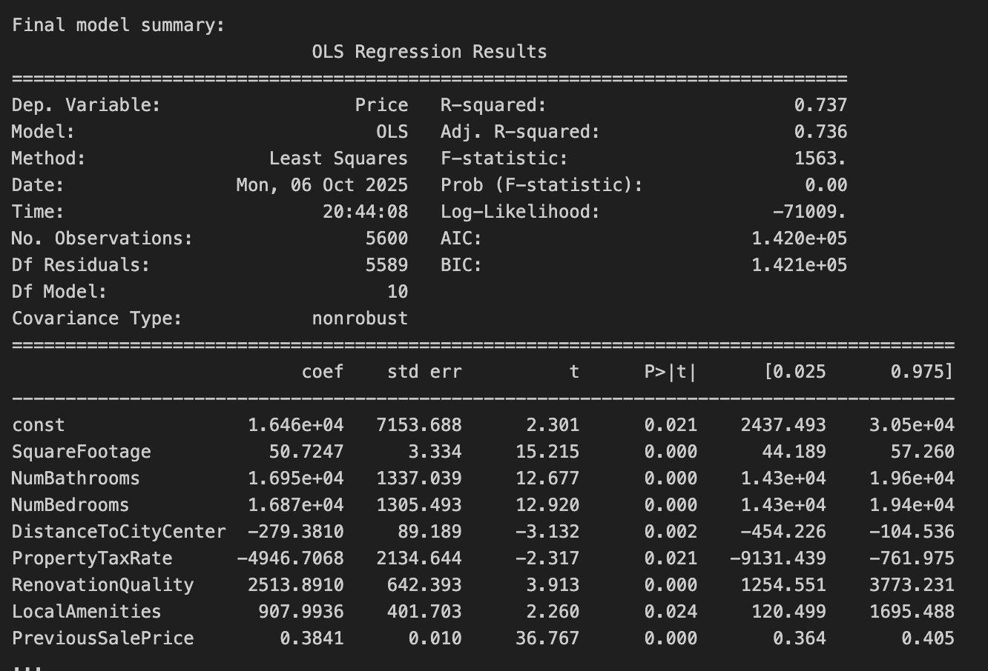
Optimized Model Summary:

3. Give the mean squared error (MSE) of the optimized model used on the training set.

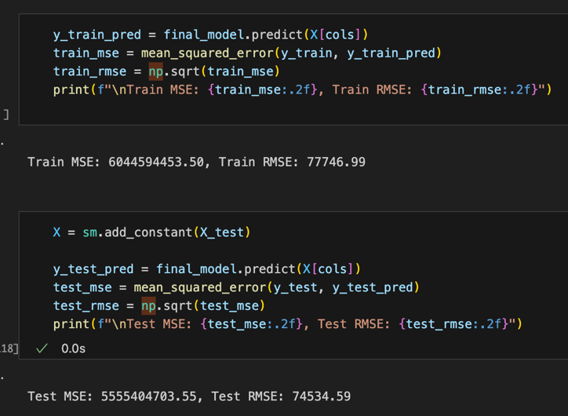
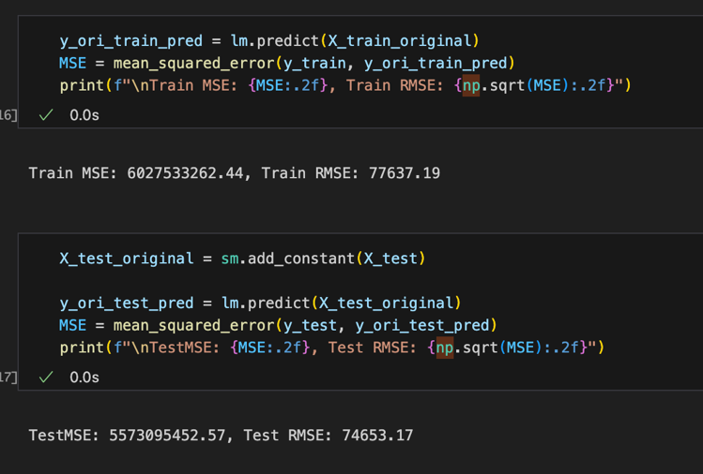
MSE before optimizing: MSE after optimizing:

4. Run the prediction on the test dataset using the optimized regression model from part D2 to give the accuracy of the prediction model based on the mean squared error (MSE).

The ‘cols’ variable contains the list of columns that were kept from optimizing the model.


E. Summarize your data analysis by doing the following:
1. List the packages or libraries you have chosen for Python or R and justify how each item on the list supports the analysis.

- import pandas as pd: Used for creating data frames, transforming data frames (e.g. dropping columns), and reading/writing csv files.
- import matplotlib.pyplot as plt: Used for creating univariate and bivariate graphs to understand the distributions of each variable and the independent vs dependent variable.
- import seaborn as sns: Used to create bar plots for the categorical variables and the dependent variable.
- from sklearn.model_selection import train_test_split: Used to split the data frame into test and train
- import statsmodels.api as sm: Used to apply ordinary least square regression on the dataframe to get the summary of the model, which includes the r-squared, F statistic, coefficients, etc…
- from sklearn.metrics import mean_squared_error, r2_score: Used to get the MSE for the model.
- import numpy as np: Used for the square root function to get the squared MSE.
- from statsmodels.stats.outliers_influence import variance_inflation_factor: Used to check if the variables had multicollinearity.
- from statsmodels.stats.stattools import durbin_watson: Used to identify autocorrelation in the residuals of a regression model. This was important to identify before performing backward elimination.
- import sys: Used to identify the Python version being used.

2. Discuss the method used to optimize the model and justification for the approach.

I chose a backward elimination for optimizing the model as it iterates through the features and eliminates the less significant features through a loop and stops once all the features have a significant value of less than .05. Keeping features with a significant value of less than .05 means that there is strong evidence against the null hypothesis and the feature does have an impact on the dependent variable. Using this approach reduces overfitting and helps the model generalize to data. Optimizing the model helped the RMSE decrease by about 100.

3. Discuss the verification of assumptions used to create the optimized model.

Using backwards elimination in order to create a linear regression model requires that the features don’t have multicollinearity. In order to handle this, the variance_inflation_factor was used to identify the features that had a VIF score of greater than 15. For the variables that did have a high score, they were removed from the dataset before the backward elimination. In addition, since the model we are performing is a linear regression model, this also verifies the assumptions of the model. In a linear regression model, there should be a lack of multicollinearity, meaning that independent variables are not highly correlated with one another. Below, using the variance_inflaction_factor verifies this assumption.

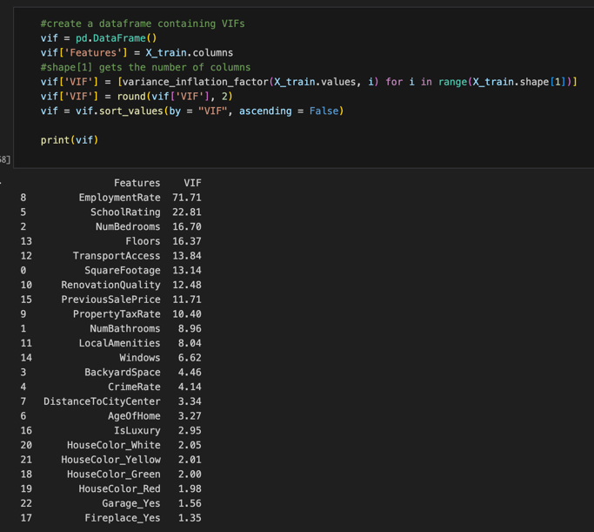
Before removing the variables, these were the VIF values, indicating that there were multiple features with multicollinearity.

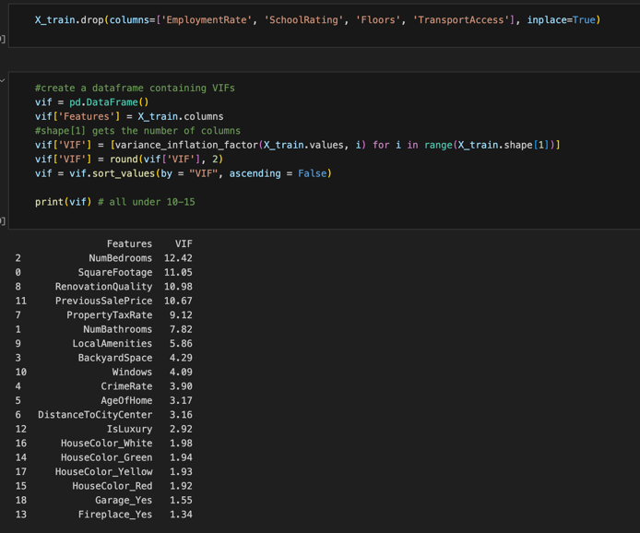

After removing the variables one by one with the highest VIF value, I verified the assumption that the dataset didn’t have multicollinearity features by running the variance_inflation_factor again, and the features VIF values are all under 15. 15 was chosen to preserve predictive features, so I only removed the strongly collinear features.

Another assumption of the backward elimination is that the residuals are independent of each other. I verified this assumption by using the durbin_watson function, and since the statistic is near 2, that suggests that there is no autocorrelation in the data (Durbin & Watson, n.d.). In addition, this is also an assumption of the linear regression model. Independence of errors ensures that the residuals are not correlated with one another, meaning that the error associated with one observation should not influence the error of another observation (GeeksforGeeks, 2025a). The Durbin-Watson statistic verifies this assumption of the linear regression model.
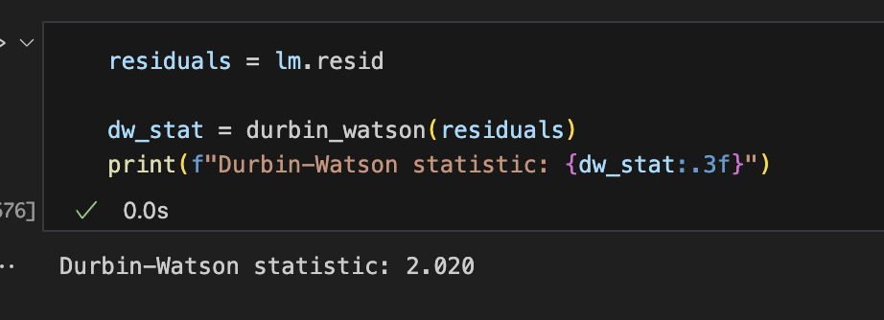

4. Provide the regression equation and discuss the coefficient estimates.

price = 16460 + 50.7247x_{SquareFootage} + 16950x_{NumBathrooms} + 16870x_{NumBedrooms} - 279.381x_{DistanceToCityCenter} – 4946.7068x_{PropertyTaxRate} + 2513.891x_{RenovationQuality} + 907.9936x_{LocalAmenities} + .3841x_{PreviousSalePrice}

If all the independent variables didn’t exist or were 0, the base price for a house would be $16,460. For example, if the square footage were 0, the number of bathrooms were 0, the number of bedrooms were 0, etc…

50.7247x_{SquareFootage}: This coefficient means that every time a square foot is added, the house price is estimated to go up by $50.7247.

16950x_{NumBathrooms}: This coefficient means that every time a bathroom is added, the house price is estimated to go up by $16,950.

16870x_{NumBedrooms}: This coefficient means that every time a bedroom is added, the house price is estimated to go up by $16,870.

-279.381x_{DistanceToCityCenter}: This coefficient means that for every unit of distance that is added to the city center, the house price decreases by $279.381.

-4946.7068x_{PropertyTaxRate}: This coefficient means that if the property tax rate increases by one, the house price decreases by $4,946.7069.

2513.891x_{RenovationQuality}: This coefficient means that if the renovation quality increases by one unit, the house price increases by $2,513.891.

907.9936x_{LocalAmenities}: This coefficient means that if the local amenities increase by one unit, the house price increases by $907.9936.

.3841x_{PreviousSalePrice}: This coefficient means that if the previous sale price increased by one, the house price would increase by $.3841.

5. Discuss the model metrics by addressing each of the following:
• the R² and adjusted R² of the training set

The R² value of the training set is .737 and the adjusted R² value is .736.

The R² values explain the proportion of variance in the dependent variable that is explained by the independent variables. So, in this case, 73.7% of the variation is explained by the independent variables. The adjusted R² value is similar to the R² value, however, it adjusts for the number of predictors in the model, penalizing unnecessary complexity. Since both the R² and adjusted R² values are similar, that means that there is very little noise in the model, and the model is a strong fit to the data.

• the comparison of the MSE for the training set to the MSE of the test set

The MSE for the training set is 6044594453.50, while the MSE of the test set is 5555404703.55. The MSE is the average of the squared differences between the predicted and actual values. Since the units are dollars and house prices are typically high, this makes sense that the MSE values are so high. Generally, the lower the MSE value, the better the model.

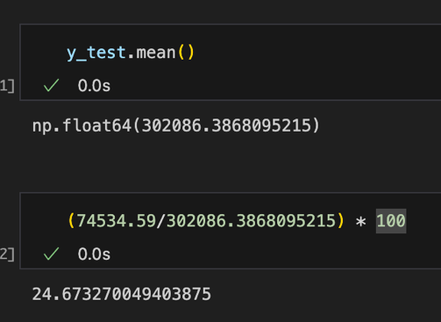
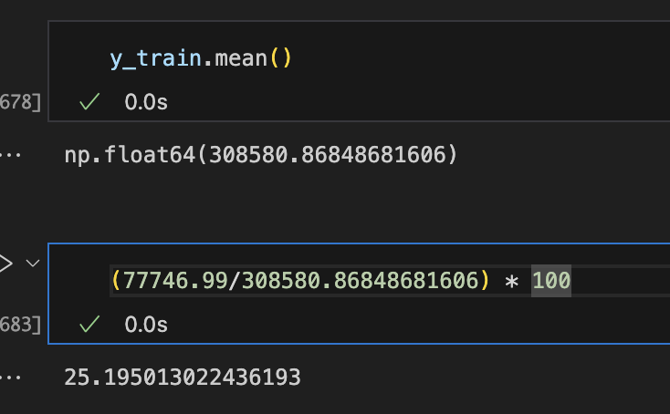
Taking the root of the MSE value is better for interpretation, as it brings the number back down to scale, since the values were initially squared to prevent negative values. So, the RMSE of the training set is 77746.99, and the RMSE of the test set is 74534.59. This means that there’s about a 25% error from the model prediction to the actual house prices for both the train and test sets. Since the test and train RMSE values are close, this means that the model has found a balanced fit that generalizes well to new data.

6. Discuss the results and implications of your prediction analysis.

The results reveal that square footage, number of bathrooms, number of bedrooms, renovation quality, local amenities, and previous sale price all increase the price of a home, while the distance to the city center and the property tax rate decrease the price of a home.

In addition, the house price predictions are off by about 25% of the time, which makes sense based on the R² value of .737. This represents a reasonably strong fit, although around 26% of the variation is still influenced by factors and did not capture other independent variables such as neighborhood safety, district quality, or broader market conditions.

The implications of these findings are meaningful for multiple individuals. Homebuyers can use these insights to prioritize features that have the strongest impact on value, while sellers can identify where investments in renovation or amenity development may result in higher sale price values. However, given the model’s 25% prediction error, its outputs should be used as guidance rather than precise forecasts, and further considerations with other features could improve predictive performance.

Another implication of using a linear regression model is that the model can’t extrapolate, so the values that it predicts outside of the original data are unreliable since the linear relationship may not continue. This makes it difficult for users to predict really expensive houses.

7. Recommend a course of action for the real-world organizational situation from part B1 based on your results and implications discussed in part E6.

Circling back to the research question of “Can I predict house prices?” the answer is yes, although the model demonstrated a strong ability to predict house prices, 25% of the time, the house price prediction may not be accurate. The recommended course of action is for the business or stakeholders to look at other features that could potentially affect the house prices, such as district ratings, flood zones, walkability, etc. If the business is looking to build a house, I would recommend that they build a house where it is closer to the city center and the property tax rate is lower, as these 2 variables contribute to decreasing a house price. If the business is looking to sell properties, I would recommend that they look at the variables from the model that have a positive impact on the price and look for houses with those features.

Resources

Durbin, J., & Watson, G. (n.d.). Durbin-Watson Significance Tables. In Appendix A. https://www3.nd.edu/~wevans1/econ30331/Durbin_Watson_tables.pdf
GeeksforGeeks. (2025a, July 23). Assumptions of linear regression. GeeksforGeeks. https://www.geeksforgeeks.org/machine-learning/assumptions-of-linear-regression/

